 Williamson County 4-H & Page FFA Horse Show 2024 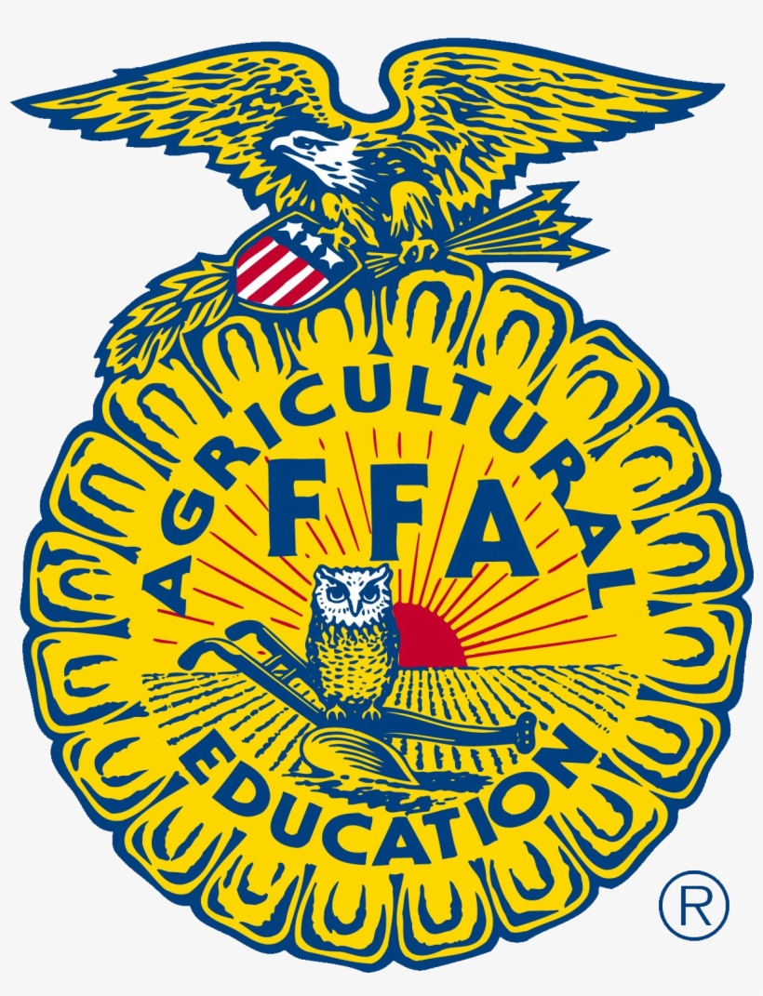
April 13, 2024
*** Register Online: https://forms.gle/LCN1ZnA2D6VmKvZX6
The Park at Harlinsdale Farm – 239 Franklin Rd, Franklin, TN 37064
*Original, Current Negative Coggins required at Check-in * Judges Decision is Final * Classes can be combined or split at Judge’s Discretion * No Refunds

Saturday, April 13, 8:00 am – English Jumping, Flat Show, & In-Hand (All classes in Large Arena, except Trail)

English Showmanship & Grooming
1. Jr. Showmanship & Grooming
2. JH Showmanship & Grooming
3. Sr. Showmanship & Grooming

Combined English & Western Halter
4. Halter Ponies
5. Halter Mares (no ponies)
6. Halter Geldings (no ponies)

Fence Classes (No height division crossover)
2’
7. Jr. Hunter Hack Pony/Horse 2’
8. JH. Hunter Hack Pony/Horse 2’
9. Sr. Hunter Hack Pony/Horse 2’
10. Alum Hunter Hack Pony/Horse 2’
11. Jr. Novice Working Hunter Pony/Horse 2’
12. Jr. Equitation Over Fences Pony/Horse 2’
13. JH. Novice Working Hunter Pony/Horse 2’
14. Sr. Novice Working Hunter Pony/Horse 2’
15. Alum Green Working Hunter Pony/Horse 2’
16. JH/Sr. Equitation Over Fences Pony/Horse 2’
17. Alum Equitation Over Fences Pony/Horse 2’
18. Jr./JH/Sr. Jumpers – Table 2* Pony/Horse 2’
19. Alum Jumpers – Table 2* Pony/Horse 2’

2’6”
20. Jr. Hunter Hack Pony/Horse 2’6”
21. JH. Hunter Hack Pony/Horse 2’6”
22. Sr. Hunter Hack Pony/Horse 2’6”
23. Alum Hunter Hack Pony/Horse 2’6”
24. Jr./JH/Sr Working Hunter Pony/Horse 2’6”
25. Jr./JH/Sr Equitation Over Fences Pony/Horse 2’6”
26. Alum Green Working Hunter Pony/Horse 2’6”
27. Alum Equitation Over Fences Pony/Horse 2’6”
28. Jr./JH/Sr. Jumpers – Table 2* Pony/Horse 2’6”
29. Alum Jumpers – Table 2* Pony/Horse 2’6”

Green Horse/Green Rider Crossrails (w/t or canter, no points, no crossover to other fence classes)
30. Green Horse/Green Rider Crossrails

Flat Classes - Hunter Under Saddle & Hunt Seat Equitation
Hunter Under Saddle/Equitation
31. Jr. Hunter Under Saddle-Pony/Horse
32. Jr. Hunt Seat Equitation-Pony/Horse
33. JH Hunter Under Saddle- Pony/Horse
34. JH Hunt Seat Equitation-Pony/Horse
35. Sr. Hunter Under Saddle-Pony/Horse
36. Sr. Hunt Seat Equitation-Pony/Horse
37. Alum Hunter Under Saddle-Pony/Horse
38. Alum Hunt Seat Equitation-Pony/Horse

Walk-Trot (no crossover into other English day riding classes)
39. Walk-Trot Under Saddle
40. Walk-Trot Hunt Seat Equitation

Walk Only (no crossover into other English day riding classes)
41. Walk-Only Under Saddle
42. Walk-Only Hunt Seat Equitation

Lead Line (English Attire; K & under; no other entry other than Western Lead Line)
43. Lead Line

Horsemanship Testing (4-H Members Only)
44. 4-H YOUTH Horsemanship Test – Level 1

Special Olympics (Open to members of the Williamson County Special Olympics – Small Arena at 2:30 pm)
45. Game with horses

English Trail – In-Hand or Ridden (Saturday 11-2pm in Small Arena)
46. Jr. English Trail
47. JH English Trail
48. Sr. English Trail
77. Alum English Trail

30 MINUTE LUNCH BREAK-at Judges Discretion

SEE POSTED JUMPING WARM UP SCHEDULE IN THE BARN AND NEAR THE ARENAS
- Schooling over jumps is only allowed during posted warm up times. No exceptions.
- A buckled, ASTM Certified helmet must be worn at all times while mounted for all youth riders (under 18)
- *Initial Course and the jump-off – Initial Course is fences 1-8. Riders have to jump the initial course with no faults. After whistle is blown rider has 45 seconds to start their jump off.

Williamson County 4-H & Page FFA Horse Show 2024
April 13, 2024
*** Register Online:
The Park at Harlinsdale Farm – 239 Franklin Rd, Franklin, TN 37064
*Original, Current Negative Coggins required at Check-in * Judges Decision is Final * Classes may be combined or split at Judge’s Discretion * No Refunds

Saturday, April 13, 2:00 pm - Western Show (All classes in Large Arena, except Trail)

Western Showmanship & Grooming
49. Jr. Showmanship (all breeds)
50. JH Showmanship (all breeds)
51. Sr. Showmanship (all breeds)

Lead Line (Western attire; K and under)
52. Lead Line

Walk-Trot (no crossover into other riding classes;
Ring may be split)
53. Walk-Trot Ranch Riding
54. Walk-Trot Ranch Horsemanship

Ranch Classes
55. Jr. Ranch Riding
56. Jr. Ranch Horsemanship
57. JH Ranch Riding
58. JH Ranch Horsemanship
59. Sr. Ranch Riding
60. Sr. Ranch Horsemanship
61. Alum Ranch Riding
62. Alum Ranch Horsemanship
Division Champion Awards (All Participants)
- Junior English Champion & Reserve
- Junior Western Champion & Reserve
- Jr. High English Champion & Reserve
- Jr. High Western Champion & Reserve
- Senior English Champion & Reserve
- Senior Western Champion & Reserve
- Alum English Champion & Reserve
- Alum Western Champion & Reserve
- Cloverbud English Champion & Reserve
- Cloverbud Western Champion & Reserve
Categories:
  - Cloverbud – Walk-Trot & Walk-Only
  - Junior – 4th & 5th grader
  - Jr. High – 6th – 8th grades
  - Senior – 9th – 12th grades
  - Alum – 18 years & older

Reining
63. Jr./JH/Sr. Reining
64. Alum Reining

Barrel Racing
65. Jr. Barrels
66. JH Barrels
67. Sr. Barrels
68. Alum Barrels

Pole Bending
69. Jr. Poles
70. JH Poles
71. Sr. Poles
72. Alum Poles

Western Trail – In Hand or Ridden (Saturday 11-2pm in Small Arena)
73. Jr. Trail
74. JH Trail
75. Sr. Trail
76. Alum Trail
- ORIGINAL, CURRENT NEGATIVE COGGINS REQUIRED AT CHECK-IN
- JUDGES DECISION IS FINAL
- CLASSES MAY BE COMBINED OR SPLIT AT JUDGE’S DISCRETION
- SCRATCHES ALLOWED, BUT NO ADDS AFTER APRIL 6TH
- NO REFUNDS

